**UNIVERSITY OF ENGINEERING AND TECHNOLOGY, LAHORE**

**(NAROWAL CAMPUS)**

**­**

**NAME :**

**ABDULAHAD HUSSAIN**

**ROLL NO. :**

**549**

**SECTION:**

**A**

**SUBJECT:**

**PROGRAMING FUNDAMENTAL**

**LAB #08:**

**Task No. 01:**

**Statement:**

Write a program that reads in the size of the side of a square then prints a hollow square of that size out of asterisks and blanks.

**Source Code:**

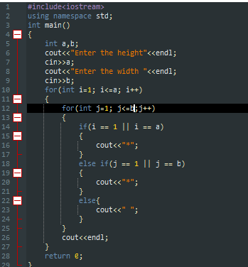

**Output:**

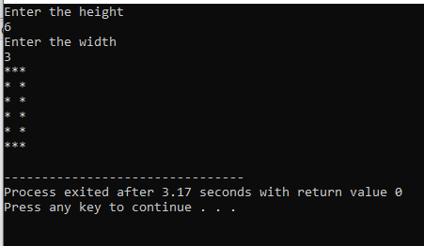

**Flow Chart:**

**Task 02:**

**Statement:**

Write a program to determine whether a number is palindrome /armstrong or not.

**Source Code:**

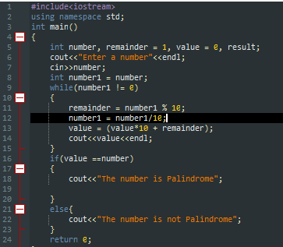

**Output:**

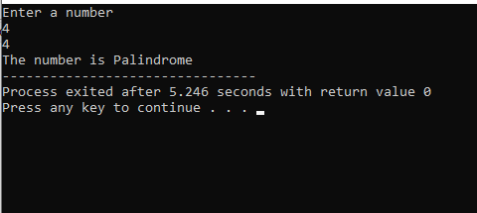

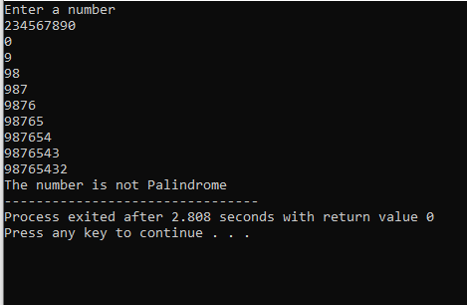

**Flow Chart:**